ASSIGNMENT 5

**Name: Jain Samkitkumar Hasmukhlal**

**Roll No.: 20 (BEIT)**

> mydata<-read.csv("C:/Documents and Settings/ADMIN/Desktop/pca_gsp.csv")

>

> attach(mydata)

> # Define variables

> X <- cbind(Ag, Mining, Constr, Manuf, Manuf_nd, Transp, Comm, Energy, TradeW, TradeR,

+ RE, Services, Govt)

> # Descriptive statistics

> summary(X)

Ag Mining Constr Manuf

Min. : 0.500 Min. : 0.000 Min. :2.900 Min. : 0.800

1st Qu.: 1.025 1st Qu.: 0.200 1st Qu.:3.825 1st Qu.: 6.250

Median : 1.800 Median : 0.450 Median :4.200 Median :10.400

Mean : 2.480 Mean : 2.624 Mean :4.338 Mean : 9.784

3rd Qu.: 2.525 3rd Qu.: 1.650 3rd Qu.:4.675 3rd Qu.:12.375

Max. :10.600 Max. :31.600 Max. :8.400 Max. :21.400

Manuf_nd Transp Comm Energy

Min. : 1.700 Min. : 1.500 Min. :1.300 Min. :1.000

1st Qu.: 4.500 1st Qu.: 2.650 1st Qu.:1.900 1st Qu.:2.500

Median : 7.150 Median : 3.200 Median :2.100 Median :2.950

Mean : 7.696 Mean : 3.476 Mean :2.398 Mean :3.112

3rd Qu.:10.500 3rd Qu.: 3.875 3rd Qu.:2.875 3rd Qu.:3.600

Max. :16.700 Max. :12.100 Max. :5.700 Max. :7.500

TradeW TradeR RE Services

Min. :2.900 Min. : 6.000 Min. :10.40 Min. : 9.60

1st Qu.:5.825 1st Qu.: 8.600 1st Qu.:13.15 1st Qu.:16.15

Median :6.300 Median : 8.900 Median :16.20 Median :18.40

Mean :6.348 Mean : 9.002 Mean :17.09 Mean :18.71

3rd Qu.:7.275 3rd Qu.: 9.850 3rd Qu.:19.15 3rd Qu.:20.77

Max. :9.100 Max. :11.500 Max. :35.40 Max. :32.30

Govt

Min. : 9.00

1st Qu.:10.90

Median :12.25

Mean :12.93

3rd Qu.:14.55

Max. :21.30

> cor(X)

Ag Mining Constr Manuf

Ag 1.00000000 -0.06446456 0.08498040 0.03208436

Mining -0.06446456 1.00000000 -0.02146761 -0.42367130

Constr 0.08498040 -0.02146761 1.00000000 -0.12993364

Manuf 0.03208436 -0.42367130 -0.12993364 1.00000000

Manuf_nd -0.14533029 -0.13794386 -0.31780734 0.20372851

Transp 0.27917762 0.61153483 0.07516000 -0.35693665

Comm -0.18418380 -0.19271386 -0.02310018 -0.31738049

Energy 0.04325752 0.39044648 0.01300031 -0.05083012

TradeW 0.24539204 -0.55305518 -0.08691544 0.27073259

TradeR 0.09464267 -0.39599385 0.40113015 0.19462642

RE -0.30129373 -0.40633100 -0.25294548 -0.18205552

Services -0.32191590 -0.45971557 0.32364308 -0.15904326

Govt 0.11033873 0.23067866 0.18104989 -0.41051203

Manuf_nd Transp Comm Energy

Ag -0.14533029 0.27917762 -0.18418380 0.04325752

Mining -0.13794386 0.61153483 -0.19271386 0.39044648

Constr -0.31780734 0.07516000 -0.02310018 0.01300031

Manuf 0.20372851 -0.35693665 -0.31738049 -0.05083012

Manuf_nd 1.00000000 -0.17641840 -0.09988080 0.07091362

Transp -0.17641840 1.00000000 -0.04911955 -0.05572106

Comm -0.09988080 -0.04911955 1.00000000 -0.16859364

Energy 0.07091362 -0.05572106 -0.16859364 1.00000000

TradeW 0.03900687 -0.21353750 0.33018068 -0.26707721

TradeR -0.12082255 -0.14778210 0.12467627 0.02953892

RE -0.13333291 -0.50348731 0.11971090 -0.37884901

Services -0.45771026 -0.42168031 0.30914590 -0.31383479

Govt -0.23707649 0.42750613 0.19333215 0.04539830

TradeW TradeR RE Services Govt

Ag 0.24539204 0.09464267 -0.30129373 -0.3219159 0.1103387

Mining -0.55305518 -0.39599385 -0.40633100 -0.4597156 0.2306787

Constr -0.08691544 0.40113015 -0.25294548 0.3236431 0.1810499

Manuf 0.27073259 0.19462642 -0.18205552 -0.1590433 -0.4105120

Manuf_nd 0.03900687 -0.12082255 -0.13333291 -0.4577103 -0.2370765

Transp -0.21353750 -0.14778210 -0.50348731 -0.4216803 0.4275061

Comm 0.33018068 0.12467627 0.11971090 0.3091459 0.1933322

Energy -0.26707721 0.02953892 -0.37884901 -0.3138348 0.0453983

TradeW 1.00000000 0.16636809 0.04049752 0.2390834 -0.3428307

TradeR 0.16636809 1.00000000 -0.30862993 0.2021658 0.2865884

RE 0.04049752 -0.30862993 1.00000000 0.5192887 -0.3506442

Services 0.23908339 0.20216576 0.51928874 1.0000000 -0.1795611

Govt -0.34283068 0.28658841 -0.35064424 -0.1795611 1.0000000

> View(mydata)

> View(X)

> View(mydata)

> # Principal component analysis

> pca1 <- princomp(X, scores=TRUE, cor=TRUE)

> summary(pca1)

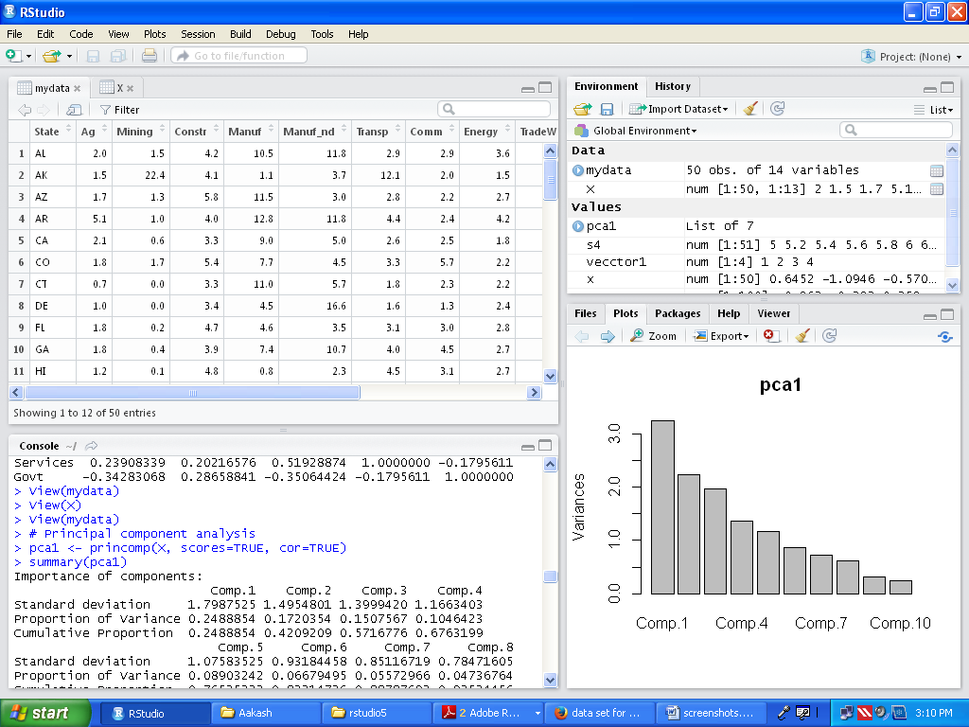

Importance of components:

Comp.1 Comp.2 Comp.3 Comp.4

Standard deviation 1.7987525 1.4954801 1.3999420 1.1663403

Proportion of Variance 0.2488854 0.1720354 0.1507567 0.1046423

Cumulative Proportion 0.2488854 0.4209209 0.5716776 0.6763199

Comp.5 Comp.6 Comp.7 Comp.8

Standard deviation 1.07583525 0.93184458 0.85116719 0.78471605

Proportion of Variance 0.08903242 0.06679495 0.05572966 0.04736764

Cumulative Proportion 0.76535232 0.83214726 0.88787692 0.93524456

Comp.9 Comp.10 Comp.11 Comp.12

Standard deviation 0.5641253 0.4851322 0.38943836 0.36945813

Proportion of Variance 0.0244798 0.0181041 0.01166633 0.01049995

Cumulative Proportion 0.9597244 0.9778285 0.98949478 0.99999473

Comp.13

Standard deviation 8.279806e-03

Proportion of Variance 5.273476e-06

Cumulative Proportion 1.000000e+00

> # Loadings of principal components

> loadings(pca1)

Loadings:

Comp.1 Comp.2 Comp.3 Comp.4 Comp.5 Comp.6 Comp.7 Comp.8

Ag -0.135 -0.385 -0.373 0.411 0.245 -0.433 -0.277

Mining -0.470 0.260 0.164 0.276 0.148

Constr -0.393 -0.257 0.350 0.196 0.370 -0.499

Manuf 0.183 0.376 -0.375 0.147 0.111 -0.198 0.151 0.500

Manuf_nd 0.459 -0.465 -0.217 0.102 -0.592

Transp -0.418 -0.147 -0.365 0.143 -0.169 0.302

Comm 0.152 -0.316 -0.343 -0.550 0.267 0.145 0.101

Energy -0.247 0.138 0.416 -0.202 0.689 -0.199

TradeW 0.315 -0.290 -0.442 0.353 0.254

TradeR -0.261 -0.507 0.227 -0.252 -0.143 -0.146 0.100

RE 0.363 0.447 0.173 -0.359 -0.106

Services 0.380 -0.384 0.127 0.183 0.125 0.101 0.133

Govt -0.289 -0.369 -0.295 -0.306 -0.428 0.121

Comp.9 Comp.10 Comp.11 Comp.12 Comp.13

Ag 0.152 -0.217 -0.286 0.206

Mining -0.116 -0.475 -0.282 0.500

Constr 0.371 -0.141 0.256

Manuf 0.387 0.138 0.406

Manuf_nd -0.102 0.142 -0.122 0.338

Transp -0.264 -0.108 0.507 0.407 0.144

Comm 0.436 -0.383

Energy 0.116 0.282 0.286

TradeW -0.253 0.455 -0.322 0.210 0.112

TradeR -0.515 -0.432 -0.181 0.106

RE -0.169 -0.127 0.496 0.451

Services -0.222 0.204 0.458 -0.460 0.320

Govt 0.171 0.548 0.238

Comp.1 Comp.2 Comp.3 Comp.4 Comp.5 Comp.6 Comp.7

SS loadings 1.000 1.000 1.000 1.000 1.000 1.000 1.000

Proportion Var 0.077 0.077 0.077 0.077 0.077 0.077 0.077

Cumulative Var 0.077 0.154 0.231 0.308 0.385 0.462 0.538

Comp.8 Comp.9 Comp.10 Comp.11 Comp.12 Comp.13

SS loadings 1.000 1.000 1.000 1.000 1.000 1.000

Proportion Var 0.077 0.077 0.077 0.077 0.077 0.077

Cumulative Var 0.615 0.692 0.769 0.846 0.923 1.000

> #pca1$loadings

> # Scree plot of eigenvalues

> plot(pca1)

> screeplot(pca1, type="line", main="Scree Plot")

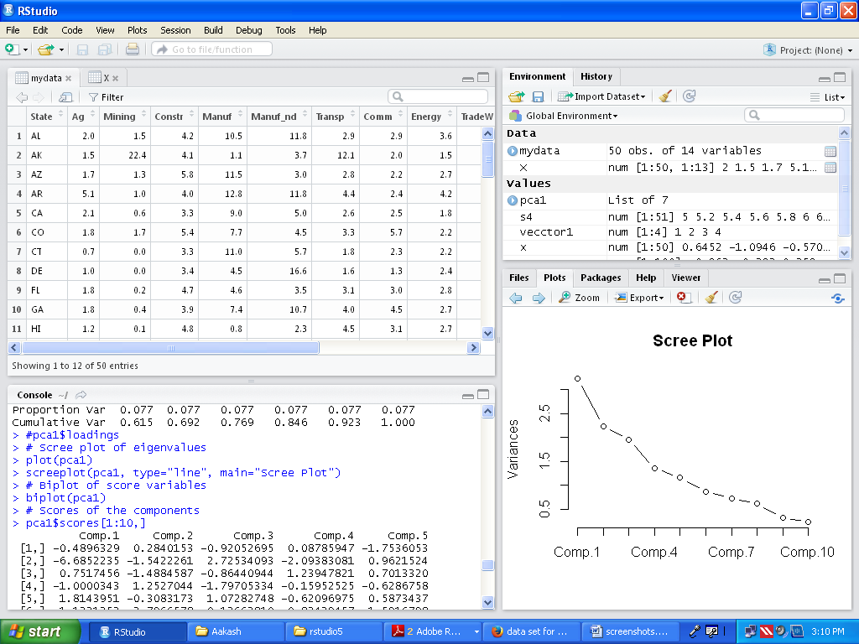

> # Biplot of score variables

> biplot(pca1)

> # Scores of the components

> pca1$scores[1:10,]

Comp.1 Comp.2 Comp.3 Comp.4 Comp.5

[1,] -0.4896329 0.2840153 -0.92052695 0.08785947 -1.7536053

[2,] -6.6852235 -1.5422261 2.72534093 -2.09383081 0.9621524

[3,] 0.7517456 -1.4884587 -0.86440944 1.23947821 0.7013320

[4,] -1.0000343 1.2527044 -1.79705334 -0.15952525 -0.6286758

[5,] 1.8143951 -0.3083173 1.07282748 -0.62096975 0.5873437

[6,] 1.1231352 -2.7966578 0.12662810 -0.83439457 -1.5916798

[7,] 2.4543289 0.8838887 2.26111646 -0.17696795 1.0153673

[8,] 0.9918322 2.9538499 4.02639673 0.22036149 0.4781388

[9,] 1.5476850 -2.2030680 -0.14284640 0.17108744 -0.1473670

[10,] 0.9920176 -0.2998176 -0.05468377 -2.18146390 -1.8755534

Comp.6 Comp.7 Comp.8 Comp.9 Comp.10

[1,] -0.25729127 -0.3122104 -0.1332644 0.16656810 0.12841084

[2,] -2.42578094 1.2416981 0.8350926 -0.02638485 -0.03282346

[3,] -0.40238064 0.2571765 0.1730944 0.13204988 -0.33229286

[4,] 0.31143230 -0.2804304 -0.2515513 -0.26955035 -0.91416815

[5,] -0.19317967 -0.3766092 0.6847873 -0.60181782 -0.15025628

[6,] 0.58129969 1.0428510 0.1619501 1.59879806 -1.52538907

[7,] 0.09693667 -0.2158679 0.5350483 0.06689563 -0.09648740

[8,] -1.24008960 -1.5630880 -2.3471516 0.38662079 -0.46928579

[9,] 0.46797314 -0.1884953 0.0521831 -1.26973408 -0.64521367

[10,] 0.87740143 0.9428300 -0.1629925 0.11552867 -0.08515134

Comp.11 Comp.12 Comp.13

[1,] -0.14054526 -0.11795741 -0.0022081279

[2,] 0.60577408 0.42502678 0.0038008406

[3,] -0.67623158 0.53472823 -0.0060317043

[4,] 0.62811995 0.03117104 0.0028593823

[5,] -0.05043902 -0.57785734 -0.0072707745

[6,] -0.02066718 -0.20311745 -0.0025178811

[7,] -0.09564494 0.11018733 0.0001849203

[8,] -0.24839536 0.84153331 -0.0004708541

[9,] -0.42080320 0.29586008 -0.0079586042

[10,] -0.14312824 0.31799226 -0.0020137002

